Computer Language Conding Concepts

Inactive Command Class Redirection in a Diagram
The concept of inactive command class redirection is explained in the article Inactive Command Class Redirection. The current article explains its expression in a diagram.

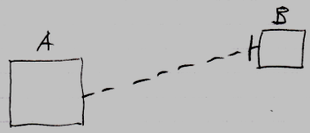

Inactive command symbol A is a square because it is an inactive command. Inactive command symbol A redirects its class to the inactive command symbol B. Symbol B is also a square because it is also an inactive command. The redirection from command A to command B is displayed as a dashed line, which is a class line. The direction of the line is indicated by a line dissector, close to symbol B. This line dissector is called an access mark. The redirection turns command A into an object with command definition B as its prototype.

See also: Inactive Command Class Redirection,
Commands

Author & Copyright: Jan-Joost van Zon Date: August 10, 2008 – August 15, 2008 Location: Oosterhout, The Netherlands Status: Finished

